Group Name, e.g. “Striders”

Title, e.g. “August Walk: Chatsworth”

Main text

Help Text
Using this template will help the Newsletter Team and Web Manager because it is formatted so that the text can be copied and pasted directly into the Newsletter and documents on the website without requiring any re-formatting.
- Edit the template to suit your group. For example, you may wish to add another heading for “Next Month’s Meeting” with some text saying “At our next meeting on . . . . we will be . . . “
- Make a copy of the template file for each new article to be submitted.
- Re-name the file to include the group name, the year/month and the subject (if applicable),
e.g. Striders 2026-09 Chatsworth walk
- The following pre-defined Word “Styles” are available to use in this document:
Newsletter Heading 20 (use for the Group name)
Newsletter Heading 16 (use for the article title)
Newsletter Text (use for the main body of the article)
Newsletter Text Bold
- Newsletter Bullet
- There is guidance on the next page about using Styles.
- If you wish to include photos with your article (which we encourage), please don’t embed the images within this document. The image files should be sent as separate attachments; this makes it easier to downloaded them and save in our photos archive.
- Ideally, articles for the Newsletter with any associated photos should be no more than 1 page long, although longer articles can be accommodated on the website. Shorter articles about half a page long work well because 2 can be fitted on the same page in the Newsletter.
- Delete the help text before writing your article.

Using “Styles” in Word Documents
The Styles menu is usually located in the Home tab at the top of the page. Click the down arrow on the right of the Styles menu to display more Styles:

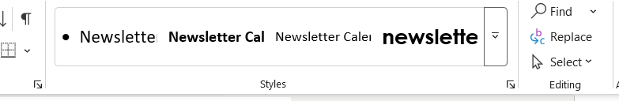

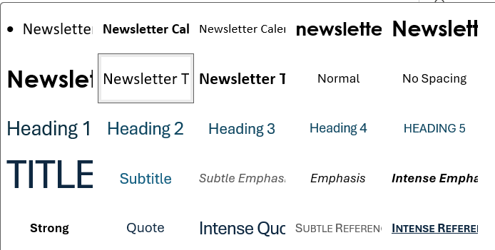

It is probably more convenient to use the Styles task pane which can be opened by clicking the diagonal arrow at the bottom right of the Styles menu:
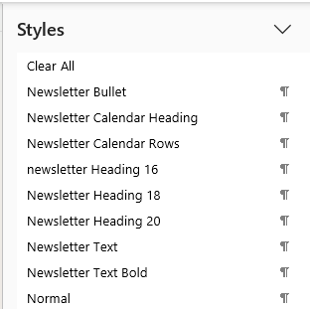

(Pressing the Ctrl, Alt, Shift and S
keys simultaneously is another way
of opening the Styles task pane)

You can re-size the Styles task pane and drag it to a convenient location on the screen, such as to the right hand side of your document.
To apply a Style to any text, highlight the text and click the required Style in the Styles menu or in the Styles task pane.

